Sprint 1 - Endurance Design Document

November , 2020

**Table of Contents**

1. Executive Summary 3

1.1 Project Overview 3

1.2 Purpose and Scope of this Specification 3

2. Product/Service Description 3

2.1 Product Context 3

2.2 User Characteristics 3

2.3 Assumptions 3

2.4 Constraints 4

2.5 Dependencies 4

3. Requirements 4

3.1 Functional Requirements 4

3.2 Security 5

3.2.1 Protection 5

3.2.2 Authorization and Authentication 5

3.3 Portability 5

4. Requirements Confirmation/Stakeholder sign-off 5

5. System Design 5

5.1 Algorithm 5

5.2 System Flow 6

5.3 Software 6

5.4 Hardware 6

5.5 Test Plan 6

5.6 Task List/Gantt Chart 7

5.7 Staffing Plan 7

# Executive Summary

## Project Overview

This project is an endurance challenge using Sphero to run a rectangular course. The target audience of this project is any person new to coding and robotics as well as Monmouth University students looking to expand their knowledge on the subject. The ease of use and access of the application needed to run the project open a wide range of those who can examine and run the project for themselves. With access to a Sphero robot, anyone can communicate to it using this project to learn more on robotics and coding in general.

## Purpose and Scope of this Specification

Describe the purpose of this specification and its intended audience. Include a description of what is within the scope and what is outside of the scope of these specifications. For example:

**In scope**

This document addresses requirements related to Sprint 1 of Robotics Triathlon Project :

* Bluetooth Connection
* Reliability
* Correct Code

**Out of Scope**

The following items in Sprint 1 of Robotics Triathlon Project are out of scope:

* Enough Space to test the code.
* Portability is necessary to be able to test the robots code in different environments
* Testing code

(Phase 3 will be considered in the development of the requirements for Phase 2, but the Phase 3 requirements will be documented separately.)

# Product/Service Description

## Product Context

This project is reliant upon other interfaces including Sphero Edu, a Sphero robot and a basic operating system on which the application of Sphero Edu can run. Using Sphero Edu as a compiler and the direct source of communication to the Sphero robot, the project is reliant on it to run the code in order for the robot to run its course. Overall, an operating system is needed for the application Sphero Edu in which the project was created and is ran. From this a Sphero robot is needed to show the communication happening between the project code and the robot itself.

## User Characteristics

Create general customer profiles for each type of user who will be using the product. Profiles should include:

* Student
* Faculty
* Child
* Researcher
* Extremely limited experience needed in block code or javascript
* Ability to read

## Assumptions

* Access to IOS / MacOS / Microsoft Windows
* Access to a Sphero robot
* Access to Sphero edu
* Very basic understanding of block code

## Constraints

Describe any items that will constrain the design options, including

* Specific instructions given on what tasks the robot needs to complete
* Specific course outline the robot must follow
* Limits of Sphero robot
* Limited options for actions the robot can do in block code of Sphero Edu

## Dependencies

List dependencies that affect the requirements. Examples:

* Project will require a singular download of Sphero Edu
* Project will require an outline of course layout
* Project will require ample space for robot movement

# Requirements

## Functional Requirements

In the example below, the requirement numbering has a scheme - BR_LR_0## (BR for Business Requirement, LR for Labor Relations). For small projects simply BR-## would suffice. Keep in mind that if no prefix is used, the traceability matrix may be difficult to create (e.g., no differentiation between '02' as a business requirement vs. a test case)

The following table is an example format for requirements. Choose whatever format works best for your project.

For Example:

|  |  |  |  |  |  |
| --- | --- | --- | --- | --- | --- |
| **Req#** | **Requirement** | **Comments** | **Priority** | **Date Rvwd** | **SME Reviewed / Approved** |
| ENDUR_01 | Portability | Ability to run project in separate locations | 2 | 11/16/20 | Approved |
| ENDUR_02 | Reliability | Ability to run the robot consistently and coincide with its code | 1 | 11/16/20 | Approved |
| ENDUR_03 | Bluetooth connection | Must have bluetooth to test the Robot | 1 | 11/16/20 | Approved |
| ENDUR_04 | Code | Robot must have proper code to execute the program properly | 1 | 11/16/20 | Approved |
| ENDUR_05 | Sufficient Space | There must be an ample amount of space in order for the robot to run the course correctly | 2 | 11/16/20 | Approved |

## Security

### Protection

Specify the factors that will protect the system from malicious or accidental access, modification, disclosure, destruction, or misuse. For example:

* Host restriction on which party can access code
* Host restriction on which party can edit code
* Restriction on which parties can communicate to project
* Sphero edu mandatory for use

### Authorization and Authentication

Authorization for this project came from Gil D. Eckert, M.S. of Monmouth University as well as from team members Daniel Fleming, Frank Figueroa and Santino Galati. All authorization was made through the use of [Github](https://github.com/frankf1204/endurance).

## Portability

If portability is a requirement, specify attributes of the system that relate to the ease of porting the system to other host machines and/or operating systems. For example,

* 0% of components with host-dependent code;
* 0% of code that is host dependent;
* Use of portable language; Use of block code
* Use of Sphero Edu compiler
* Use of any operating system with Sphero Edu installed;
* Need for course layout of Sprint 1; Endurance

# Requirements Confirmation/Stakeholder sign-off

Include documentation of the approval or confirmation of the requirements here. For example:

|  |  |  |
| --- | --- | --- |
| **Meeting Date** | **Attendees (name and role)** | **Comments** |
| 11/14/20 | Daniel Fleming | confirmed all |
| 11/16/20 | Daniel Fleming, Santino Galati, Frank Figueroa | confirmed all |

# System Design

## Algorithm

Develop and describe here the algorithm that will be used to provide the required performance of your software

1. Start Robot

2. Input robot color to “Green”

3. Input speech “Ready set go”

4. Input robot movement roll 0 degrees degrees at speed “60” for 10 seconds

5. Input spin 90 degrees for 1 second

6. Input robot movement roll 0 degrees degrees at speed “60” for 6 seconds

7. Input spin 90 degrees for 1 second

8. Input robot movement roll 0 degrees degrees at speed “60” for 10 seconds

9. Input spin 90 degrees for 1 second

10. Input robot movement roll 0 degrees degrees at speed “60” for 6 seconds

11. Input spin 90 degrees for 1 second

12. Input robot color to “Red”

13. Input speech “Im done and I need water”

14. End program

## System Flow

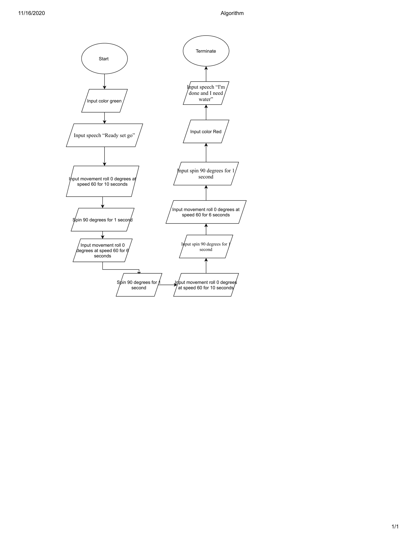

## Software

The use of Sphero Edu in developing and deploying this application is needed. The source code for this specific application is block code for its ease of use and universibility. The application then converts block code into javascript to communicate with the Sphero robot directly.

## Hardware

To test and demonstrate this application, the operating systems of Microsoft Windows, IOS and MacOS were used alongside Sphero Edu to both develop code and communicate with the Sphero robot. The ease of use related to both operating systems made them idle components for this project as they provide ease of access to the Sphero Edu application which is needed to communicate with the robot. Sphero Edu was chosen for its compatibility with the robot at hand and its use of block code, providing ease of use with limited software engineering expertise.

## Test Plan

Include a test plan showing all unit tests performed for this application, Include test rational, test date, staff member, pass/fail status

|  |  |  |  |  |  |
| --- | --- | --- | --- | --- | --- |
| **Reason for Test Case** | **Test Date** | **Expected Output** | **Observed Output** | **Staff Name** | **Pass/Fail** |
| Attempt 1 | 11/14 | Robot will move in rectangular outline | Robot moved straight with slight roll at certain points | Daniel F. | Fail |
| Observe fixed turning | 11/16 | Robot will move in rectangular outline | Robot moved in straight line | Daniel F. | Fail |
| Observe fixed turning | 11/16 | Robot will move in rectangular outline | Robot moved in a rectangle | Daniel F. | Pass |
| Better match the distances given before turning | 11/16 | Robot will better reach distance requirements before turning | Robot met distance before turning. Completed Rectangle | Frank F. | Pass |

## Task List/Gantt Chart



## Staffing Plan

Insert a chart/table that depicts the roles and responsibilities of each team member that worked on this project

|  |  |  |  |
| --- | --- | --- | --- |
| Name | Role | Responsibility | Reports To |
| Daniel Fleming | Task Manager | Gantt Chart, System Design Document, Lead in managing tasks | Frank F.  Santino G. |
| Frank Figueroa | Code Tester | Run Code, Test Plan, Edit Code | Daniel F.  Santino G. |
| Santino Galati | Team Member | Algorithm, Flow Chart, Block Code, Requirements, Assist in SDD | Daniel F.  Frank F. |